ASSIGNMENT-08

i. Find the number of student in CSE second year.
SELECT COUNT (*) AS NO_OF_STUDENT FROM STUDENT2063 WHERE DEPTCODE='CSE' AND SEMESTER='SEM3' OR SEMESTER='SEM5';
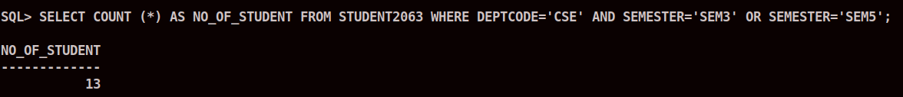
ii. Find the number of students whose marks of any subject is available.
SELECT COUNT (*) AS AVAILABLE FROM STUDENT2063 , RESULT2063 WHERE STUDENT2063.ROLLNO = RESULT2063.ROLLNO;
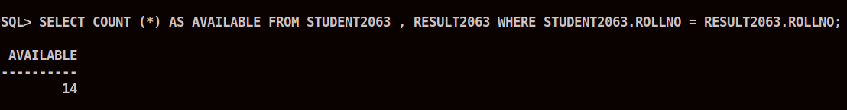
iii. Find total number of faculty.
SELECT COUNT(*) AS TOTAL_FACULTY FROM FACULTY2063;
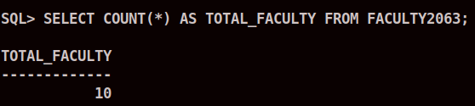
iv. Find the 5th semester student(s) who got maximum marks in a subject.
SELECT S.NAME, R.MARKS, SU.SUBJECTNAME FROM STUDENT2063 S, RESULT2063 R, SUBJECT2063 SU WHERE S.ROLLNO = R.ROLLNO AND S.SEMESTER = 'SEM5' AND R.SUB_CODE = SU.SUBJECTCODE AND SU.SUBJECTNAME = 'Discrete Mathematics' AND R.MARKS = (SELECT MAX(MARKS) FROM RESULT2063 WHERE SUB_CODE = SU.SUBJECTCODE);

v. Find the roll number of a student who got maximum marks in CS501.
SELECT ROLLNO , MARKS FROM RESULT2063 WHERE MARKS = (SELECT MAX(MARKS) FROM RESULT2063 WHERE SUB_CODE ='CS501');
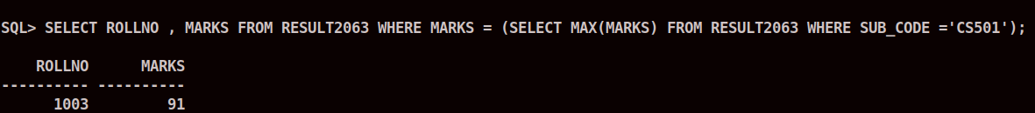
vi. Display average marks of CS502.
SELECT AVG(MARKS) FROM RESULT2063 WHERE RESULT2063.SUB_CODE ='CS502';
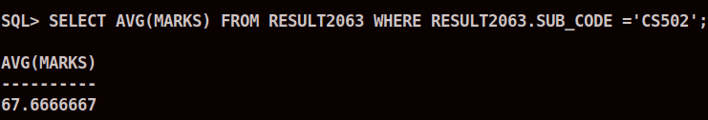
vii. Find the number of students in each department with their department code.
SELECT DEPTCODE , COUNT(*) AS NUMBER_OF_STUDENTS FROM STUDENT2063 GROUP BY(DEPTCODE);
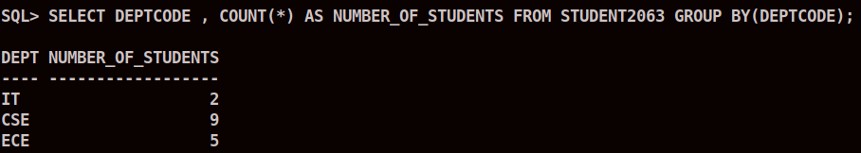
viii. Find the number of students in each department with their department name.
SELECT DEPARTMENT2063.DEPTCODE, COUNT(*) AS NUMBER_OF_STUDENTS, DEPARTMENT2063.DEPTNAME FROM STUDENT2063, DEPARTMENT2063 WHERE DEPARTMENT2063.DEPTCODE = STUDENT2063.DEPTCODE GROUP BY DEPARTMENT2063.DEPTCODE, DEPARTMENT2063.DEPTNAME;
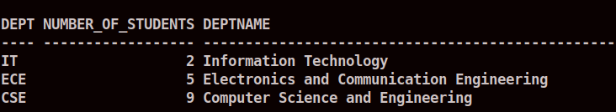
ix. Find the Department with more than three faculty.
SELECT D.DEPTNAME FROM DEPARTMENT2063 D WHERE (SELECT COUNT(TEACHER) FROM SUBJECT2063 S WHERE S.DEPTCODE = D.DEPTCODE) >= 3;
x. Find the student name and roll no who get more than 80 in at least two subject.
SELECT NAME, ROLLNO FROM STUDENT2063 WHERE (SELECT COUNT(*) FROM RESULT2063 R , STUDENT S WHERE S.ROLLNO = R.ROLLNO AND R.MARKS > 80) >= 2;
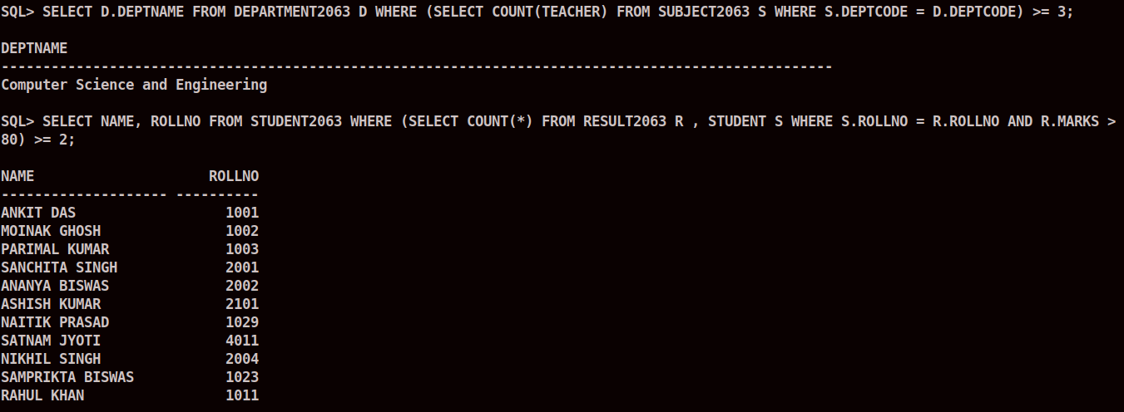
xi. Find the student name and roll no who get more than 70 in average.
SELECT S.NAME, S.ROLLNO FROM STUDENT2063 S WHERE (SELECT AVG(MARKS) FROM RESULT2063 R WHERE R.ROLLNO = S.ROLLNO) > 70;
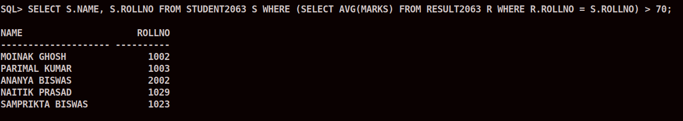
xii. Display number of subject semester wise in dept CSE.
SELECT SEMESTER, COUNT(*) FROM SUBJECT2063 WHERE DEPTCODE='CSE' GROUP BY(SEMESTER);
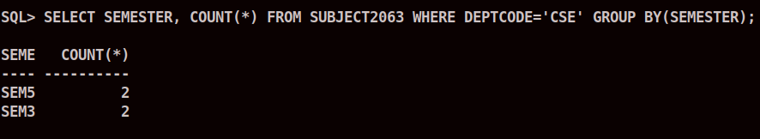
xiii. Find the department name with maximum number of student.
SELECT DEPTNAME, STUDENTALLOTED FROM DEPARTMENT2063 WHERE STUDENTALLOTED = (SELECT MAX(STUDENTALLOTED) FROM DEPARTMENT2063);
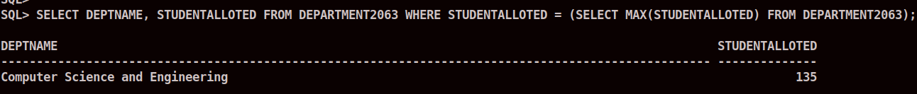
xiv. Find the second highest marks of the result table.
SELECT MAX(MARKS) AS SECOND_HIGHEST FROM RESULT2063 WHERE MARKS NOT IN (SELECT MAX(MARKS) FROM RESULT2063);
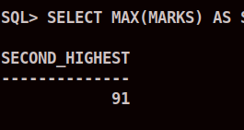
xv. Find the students name who got highest marks, subjectwise.
SELECT S.SUBJECTNAME, ST.NAME, MAX(R.MARKS) AS HIGHEST_MARKS FROM SUBJECT2063 S , RESULT2063 R ,STUDENT2063 ST WHERE S.SUBJECTCODE = R.SUB_CODE AND R.ROLLNO = ST.ROLLNO AND R.MARKS = (SELECT MAX(R2.MARKS) FROM RESULT2063 R2 WHERE R2.SUB_CODE = S.SUBJECTCODE) GROUP BY S.SUBJECTNAME, ST.NAME;

